INTL 201 - Final Synthesis/Collage Assignment (15 points)

What is this assignment? A final course reflection in a visual and verbal format that will be viewed by a subset of your fellow students. It is one PowerPoint slide with multiple images and a brief written description + reflection incorporated in the notes function of Power Point.

Why? To provide you with a creative and multi-modal way of demonstrating your thoughts on one of the global issues studied this term.

Each of you is a whole person, interacting with your environment as a member of the global community. Your heads, hearts, and bodies reflect upon and move into new spaces. As an alternative to only writing about how you situate yourself in both your local and global community, the assignment lets you find and compile a visual representation of these links drawing on creative and holistic dimensions of your learning. A visual representation of the themes and ideas we are exploring will prompt critical thinking and work to help you make connections between topics examined in the material we have viewed, read, written about, and discussed.

I would also like for you to write about that visual representation as a means to think about the choices you have made with respect to ONE of the areas listed below:
cultural globalization OR development

. As you may notice in the activities section from Chapter Eight (Food), there are a range of levels of engagement with a particular global issue. Among them:

1 2 3 4 5
Identify Gather Compare/ How does this How might you
local/global information contrast relate to your engage in a
problems what you current program level of
associated first knew & of study? Stewardship
with issue what you know or activism
Now while in school?

For this assignment, you need to look at all 5 of these. However it is entirely possible you will not have much to say about #4 or #5. In the text you write in the notes to accompany your Power Point, you must comment on 1,2, and 3. You may comment on 4 and 5.

Assignment: You will work to represent either the theme of cultural globalization or development in a collage, a group of images arranged in a way that is both visually appealing and sends a strong message. In addition, you can think about broad notions addressed in these two chapters such as being connected, making a difference, understanding links between history, ideology, and behavior, or the local- global (glocal) continuum. In the collage, you can represent anything you have identified as interesting that would prompt a curious investigation and that would enable you to find images that represent your interaction or positioning regarding one of the five issues as well as where you would place yourself on the 7- point continuum above. You will also write a short essay identifying the choices you made as creator of this project and how each image supports your nuanced understanding of the connections between you and the world that we are seeking to understand in this class.

Process:
- Create your collage using a single PowerPoint slide, and upload this file to the designated discussion board area. I have created a discussion forum for you all to share with your collages.
- Find images that represent your specific “filter” and insert them into the PowerPoint to create a collage. The image below gives you a general idea of what to do:
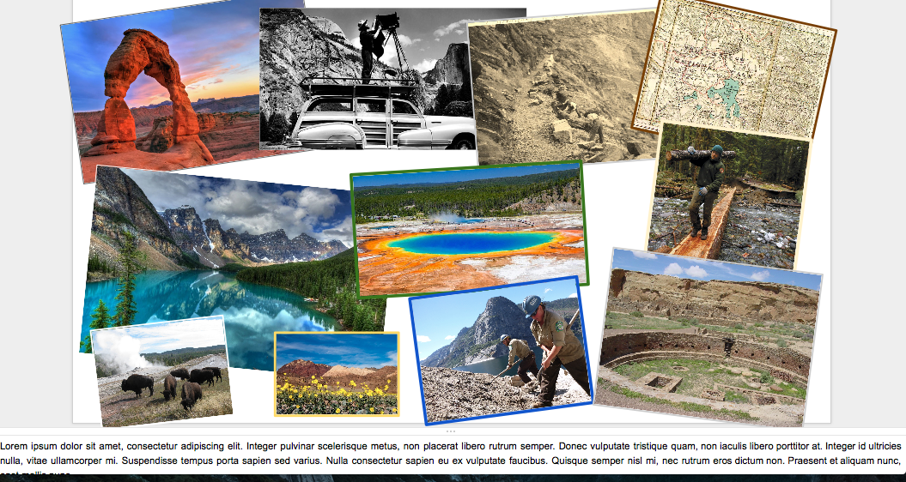

- Create an accompanying document where you’ll share the written aspect of the assignment. Share this with the class as well. You can craft this on MS Word and then paste it to the notes section of PowerPoint. This will be a 350-500 word double spaced paper whereby you discuss why you chose which images and how they represent the theme you explored.

Guidelines for written work:

- Specifically, describe what issue you are focusing on. What key links are you establishing in your collage and why? The collage is like a literature review. A literature review is not a laundry list of articles. Rather, a literature review is how the articles interact and/or relate to each other. That is how you need to think about the collage. It is not just a bunch of images; rather: how do the images interact and relate to communicate a meaningful message?
- What principles did you use to begin looking for images?
- What evidence are you using to support your collection of images? Why are the images you have chose necessary and sufficient for you to illustrate your ideas?
- What particular significance does each picture have for you in terms of illuminating a better understanding of your position in the local - global continuum regarding security, food, health, energy, or environment?
- Compare and contrast what you first thought about your issue and what you now think about it.
- Conclusion

Resources:
In addition to Google Images, there are academic resources that you might find more specific and helpful as you work to locate images and construct a visual representation of the theme you selected. For example, the Library of Congress has some wonderful photographs and images on this site. There are also several state archives that have images digitized. There are several databases, archives and academic resources, such as the New York Public Library and Getty Images (www.gettyimages.com/resources/embed) so do look around perhaps with the search engine term “royalty-free images.” The PSU library also has several databases, including Artstor, a non-profit resource, that consists of images in art, architecture, the humanities, and social sciences. Go to the library home page and follow the link to “research tools and collections.” See what you might find.

Do not limit yourself to photographs or paintings; visual representations of your theme can take different forms, so be creative and thoughtful as you identify these images. You can certainly create an original piece, take a photograph of it, and upload this image as well.

Adapted with permission from Dr. Jennifer Kerns, Dept. of History, Portland State University
OAI Designers: Dr. Vince Shreck and Kari Goin, MA.

